Introduction
This assignment focused on the analysis of three distinct datasets utilizing an evolutionary algorithm of choice. The objective was to categorize sets of conditions and outputs within these datasets and evaluate the algorithm's performance. Dataset 1 and 2 were comprised of binary strings representing conditions and outputs, while Dataset 3 contained real-valued or floating-point data alongside their respective outputs.
The chosen approach for this investigation was the utilization of a Genetic Algorithm. This decision was based on the algorithm's capability to operate without domain-specific knowledge, making it adaptable for problems where prior expertise is not essential for finding potential solutions (Jacobson and Kanber, 2015). The Genetic Algorithm was employed to classify and interpret the information gleaned from the provided datasets, leveraging its inherent capacity for optimization and exploration within diverse problem spaces.

Background Research
Data mining stands as an automated process that sifts through datasets to extract valuable hidden information in the form of rules, concepts, and patterns (Maksood and Achuthan, 2016). The exponential growth of databases and data volume underscores the significance of uncovering concealed insights in various applications like customer profiling, fraud detection, and risk analysis (Jun-shan, Wei and Yan, 2009). It's often termed as the knowledge discovery process or data/pattern analysis, as it reveals latent information amid noisy, ambiguous, and actual data (Ramageri, 2010).

The burgeoning volume of data amassed daily presents both an opportunity and challenge. Companies gathering such data leverage data mining techniques to process and glean insights. However, the sensitive nature of this data raises ethical and legal concerns, especially if companies start utilizing this data beyond its original intended purposes. Major retailers, financial institutions, and even postal services utilize predictive analytics departments to understand consumer habits for more efficient marketing (Duhigg, 2012). The issue of data privacy remains paramount, emphasizing the need for ethical handling of processed data.

Within data mining, diverse models and algorithms serve the purpose of uncovering knowledge from datasets. This research narrows its focus to the classification process. Classification, a crucial facet of recent data mining, involves constructing models that predict class labels and information for new datasets. Classification Rule Mining emerges as a pivotal technique, aiming to derive a set of rules from a training dataset with predefined outputs or classes (Li, Qian and Wang, 2009). The classification process involves building a classifier using learning algorithms and validating its accuracy.

Among various classification methods, this research leans towards 'Rule-Based Classification.' This method employs IF-THEN rules for classification, where the 'IF' part (Antecedent) comprises attribute tests, logically ANDed, and the 'THEN' part (Consequent) predicts the class (Chadha and Singh, 2012).

Enter the Genetic Algorithm—an optimization technique mirroring natural biological evolution based on Darwin's theory. This algorithm navigates a population of potential solutions or the 'Search Space,' employing the 'Survival of the Fittest' principle to enhance approximations for problem-solving (Negnevitsky, 2005).

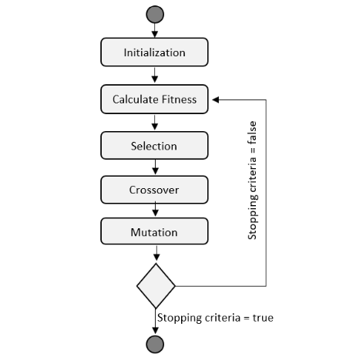
The Genetic Algorithm functions iteratively, termed as generations. Each generation yields a set of solutions evaluated based on their fitness in the problem domain. Selection, crossover, and mutation, inspired by genetic processes in nature, breed new sets, gradually refining solutions toward problem resolution. The basic representation of a genetic algorithm encapsulates this iterative and evolutionary process.

So, for this research we will be using the affirmation concepts and try to classify the given datasets and measure the performance of each with different measurements.

Experimentation
The initial two datasets feature binary numbers, while the third dataset comprises real numbers. Each condition within these datasets is represented by binary digits (0 or 1), defining the class or output of that particular condition. Employing a genetic algorithm, the aim is to classify these datasets by creating a set of rules, predicting the output or class for each rule
The rule structure mirrors a binary string, for instance, like "10110#," where the "#" acts as a wildcard. This wildcard, functioning as either a 1 or 0, serves to match against a bit within the dataset. It disregards the specific bit value in the dataset, enabling the rules to be more generalized and adaptable to fit various data points within the dataset.

Dateset1
Dataset 1 comprises 32 rows, each housing a 6-bit string of data. These strings are divided into a 5-bit condition segment and a 1-bit representation of the class or output. Consequently, the rules generated by the genetic algorithm specifically for Dataset 1 will be six units in length.

The genetic algorithm evaluates the fitness of each solution by juxtaposing the conditions present in each row of the provided dataset against the rules crafted within the potential search space. As the dataset is processed through these rules, encountering a match elevates the fitness of that particular individual. Subsequently, the algorithm proceeds to assess the next individual. This systematic comparison ensures that the fittest individuals within the population contain an ordered sequence of rules, facilitating straightforward interpretation and utilization.

The employed genetic algorithm for this dataset is relatively straightforward. It initiates with the creation of a random population. In each generation, the fittest individual is selected via tournament selection. Subsequently, single-point crossover and mutation operations are applied to produce the subsequent generation of individuals. This iterative process continues, evaluating and refining the current generation, until the predetermined number of iterations, in this case, 100 generations, is achieved.

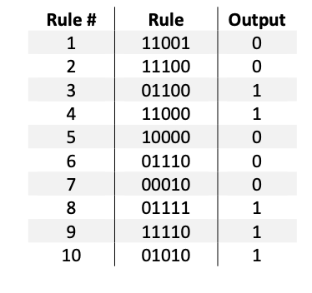
The approach of utilizing tournament selection, crossover, and mutation operations aids in continually enhancing the fitness and adaptability of the evolving population. Typically, a simple genetic algorithm can encompass anywhere from 50 to over 500 generations, with 100 generations chosen as the parameter for this research, aiming to strike a balance between computational efficiency and effective evolution of solutions.For the initial set of testing parameters, I used a population size of 100 with a 0.0 During each run of the genetic algorithm, we incorporated a mutation probability and executed the algorithm for 100 generations. Throughout these runs, we tracked both the best fitness and the average fitness of all individuals within the population. This data was utilized to visualize the algorithm's performance through a graph, showcasing the trends in fitness levels over the generations.

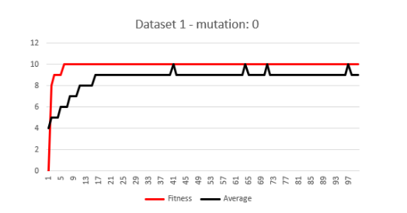
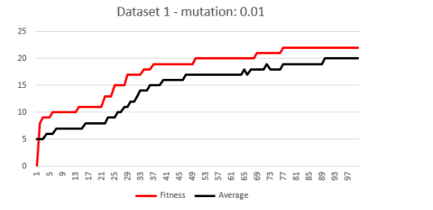
The algorithm was able to generate the following 10 rules. But this rule base is only 31% accurate when it was tested against the dataset.

The mutation probability plays a crucial role in preventing the search algorithm from becoming trapped within a local optimum. Sometimes, the sequence of selection and crossover operations can lead to stagnation at a homogeneous set of solutions. In such instances, all chromosomes become identical, impeding any improvement in the average fitness of the population. Although the solution might seem locally optimal, it restricts the algorithm's ability to reach a global optimum.

In Figure 2.0, the y-axis signifies the fitness levels, while the x-axis denotes the generations the genetic algorithm traversed. The plot illustrates a scenario where the algorithm becomes entrenched in a local optimum with a fitness level of 10. This indicates that the generated rules can only successfully classify 10 conditions out of the 32 rows within the dataset, failing to reach the global optimum.

To enhance the algorithm's performance and achieve better results, the introduction of mutation probability becomes imperative. Mutation injects randomness into the search process, akin to a random exploration, which is vital in preventing the loss of genetic diversity. This diversity is pivotal for the algorithm to explore and escape local optima, thereby fostering the potential to attain more effective and globally optimal solutions.

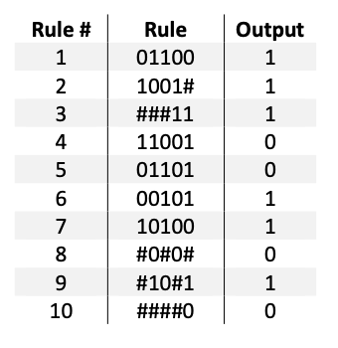
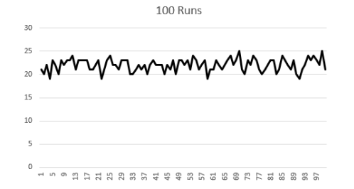
The genetic algorithm performance with a mutation probability of 0.01 shown as in Figure 2.1 has a significant improvement in the overall fitness of the solution. Hence, we get a better ruleset.

Despite attempts to enhance performance, after 100 generations, the fitness of the solution remains at 22 with an accuracy of 68%. This indicates a persistent struggle within a local optimum, failing to attain the desired global optimum of 32 for Dataset 1. Even with adjustments and iterations, the algorithm appears confined within this local realm, unable to break free towards a more optimal solution.Upon executing the genetic algorithm for approximately 100 runs using consistent parameters and rule bases, with incremental improvements in each iteration, observations (as shown in Figure 2.2) reveal a maximum fitness cap at 25, accompanied by an average fitness of 21 across all 100 runs. This trend highlights a limitation: the data within Dataset 1 lacks the requisite diversity necessary for the algorithm to converge upon a global optimum solution.These results underscore the inherent limitations within the dataset itself, suggesting that its composition and structure may not offer the necessary variability for the algorithm to explore and discover more optimal solutions. This limitation in diversity appears to constrain the algorithm's ability to transcend local optima, impeding its progress towards a more globally optimal solution.

Dataset 2
Dataset 2 comprises 64 rows, each containing a 7-bit string of data. Similar to Dataset 1, the initial 6 bits represent conditions or variables, while the final bit signifies the output. The distinguishing factor in Dataset 2 lies in the additional bit compared to the 6-bit strings in Dataset 1. Consequently, the rules generated by the genetic algorithm for Dataset 2 must be of length 7. Thankfully, the algorithm code inherently adjusts to accommodate this variation, eliminating the need for manual modifications.Despite the structural difference due to the additional bit, the fitness calculation method remains unchanged for both Dataset 1 and Dataset 2. Both datasets consist of lists of binary strings, differing solely in length.In our preliminary testing phase, we employed a population size of 100. Mutation probability, a critical parameter in genetic algorithms, is typically maintained at low levels, often ranging between 0.001 and 0.01 (Negnevitsky, 2005). To assess the algorithm's performance, we set the mutation probability to 0.001 for the duration of 100 generations, aiming to evaluate if this adjustment can enhance the algorithm's efficacy for Dataset 2.By introducing a subtle mutation probability and maintaining consistency in other parameters, we aim to discern whether these slight alterations can potentially improve the algorithm's performance in handling the slightly more complex dataset with the additional bit. This exploration is pivotal in gauging the adaptability of the algorithm and its capability to navigate variations in dataset structures.

Having such a low mutation probability did not result in a better performance from the algorithm as shown on Figure 3.0.

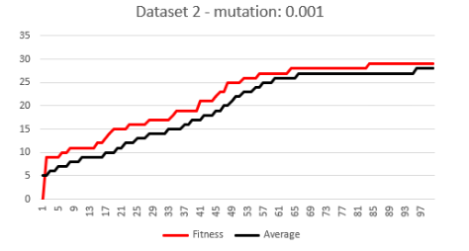
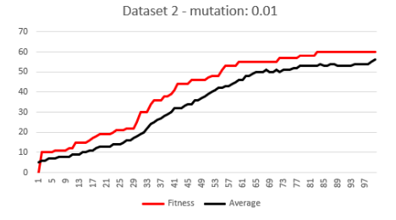
Elevating the mutation probability to 0.01 led to notable improvements in the algorithm's performance, resulting in a solution with a fitness score of 60. Figure 3.1 visually demonstrates the progressive enhancement in fitness across successive generations. This outcome suggests that maintaining a lower mutation probability doesn't consistently yield superior solutions, emphasizing the significance of mutation probability as a pivotal parameter influencing the algorithm's efficacy.
The genetic algorithm resulted in the following rules with a fitness of 60

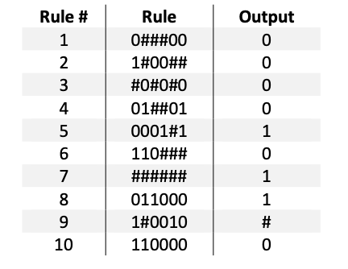

With a fitness score of 60, the ruleset produced by the genetic algorithm, under the current parameters, demonstrates an accuracy rate of 93% in effectively classifying the dataset. This high fitness score indicates a substantial capability to precisely categorize the data points within the dataset.Seeking further enhancements, a fresh population was generated, and adjustments were made to the algorithm to extend its runtime to 100 iterations. The goal was to iterate and refine the rule base developed during the initial 100 generations from the first iteration. This iterative approach aimed to capitalize on the previously generated rule base, seeking continual improvements and refinements across subsequent iterations to potentially achieve even higher fitness scores and accuracy rates.
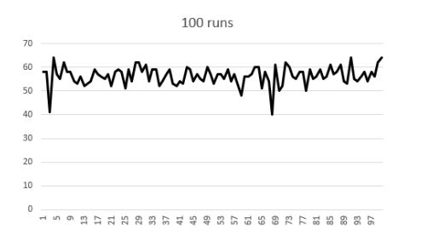

As depicted in Figure 3.3, a notable accomplishment was observed as the algorithm reached the global maximum fitness value of 64. This signifies a remarkable feat where the rule set derived from the algorithm showcases the capability to accurately classify all 64 rules within the dataset. This achievement underscores the algorithm's effectiveness in evolving and refining the rule base to encompass the entirety of the dataset with precise classifications, marking a significant stride towards optimal accuracy and performance.

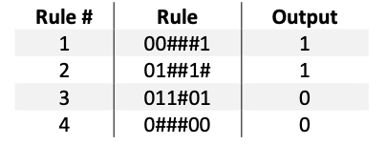
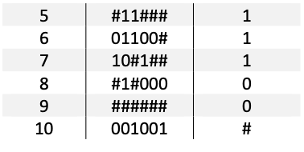

The ruleset above is the set generated by the fittest individual from all 100 runs.

Dataset 3
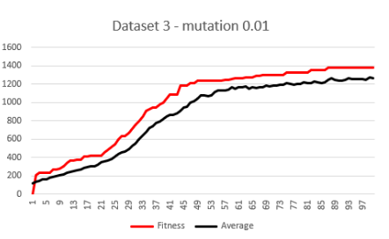
Dataset 3 presents a departure from the previous datasets, as it comprises real-valued data or floating-point numbers instead of bit strings. This dataset consists of 2000 rows, each featuring 6 real values functioning as variables and an additional bit representing the output, either 1 or 0.To adapt the existing algorithm to accommodate this new dataset, a transformation process is necessary. The real numbers within the dataset need encoding to be compatible with the algorithm's input requirements. To achieve this, each of the 6 real-valued numbers across the 2000 rows, originally between 0.0 and 1.0, is rounded off. This rounding process generates a new encoded dataset comprising 6-bit strings, preserving the condition information, with an extra bit representing the class or output.Despite the encoding transformation, the fitness calculation methodology remains unaltered, as the dataset has now been converted into binary strings, aligning with the algorithm's processing capabilities.However, due to the computational challenge posed by evaluating 2000 rows, the dataset is partitioned into two sets: a training set encompassing 75% of the data and a test set comprising the remaining 25%. The algorithm utilizes the training set to develop solutions while leveraging the test set to validate and assess the accuracy of these solutions.In our preliminary testing phase with the new dataset, we initiated the process with a population size of 100. The mutation probability was set at 0.01, and the algorithm was executed for 100 generations. These initial parameters aimed to establish a baseline for the algorithm's performance, considering the transition to a new dataset structure and the necessity for validation through a divided dataset approach.
Figure 4.0 depicts the algorithm's performance during the training phase using 75% of the encoded data from Dataset 3, equating to 1500 rows. Within this training process, the algorithm succeeded in generating an individual with a remarkable fitness score of 1377. This fittest individual, representing a culmination of the algorithm's evolution, was selected and put to the test against the remaining 25% of the encoded dataset, totaling 500 rows.

The validation process yielded promising results, showcasing the algorithm's efficacy in practical application. When tested against this separate dataset, the algorithm demonstrated an impressive accuracy rate, successfully classifying around 94% of the test dataset with precision.

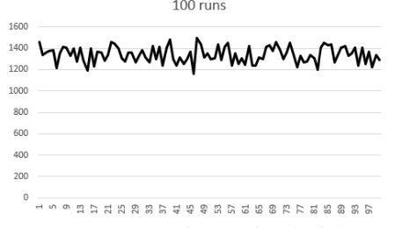
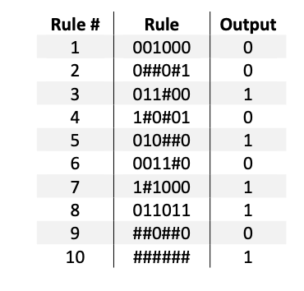
In the wake of this initial run, the rule base produced by the genetic algorithm serves as a foundational framework for further refinement and enhancement. These rules, formulated through the algorithm's iterative evolutionary process, represent a distilled set of guidelines that effectively categorize and interpret the information within the dataset, laying the groundwork for continued optimization and improvement in subsequent iterations.

Similar to the prior approach, by persistently refining the existing rules and running the genetic algorithm for 100 iterations, a remarkable fitness score of 1500 was achieved. This exhaustive iteration, illustrated in Figure 4.1, resulted in a substantial 100% accuracy rate on the test case. Despite the significant computational time of 30 minutes to complete this extensive process, the algorithm emerged with the capability to accurately classify all rows within both the training and testing sets of the dataset.This achievement underscores the algorithm's robustness and adaptability. By harnessing the rule base generated from previous iterations and subjecting it to continual refinement and optimization, the algorithm demonstrates a profound ability to thoroughly comprehend and classify all the dataset's rows, ensuring precise categorization within both the training and testing subsets.

Conclusion
In this comprehensive research endeavor, our primary objective revolved around the classification of three diverse datasets through the amalgamation of data mining techniques and the prowess of genetic algorithms. Genetic algorithms, renowned for their efficiency and adaptability in solving problems without the need for prior domain-specific knowledge, emerged as a central tool in our exploration of these datasets.Our findings underscored the crucial interplay between algorithmic parameters—such as population size and mutation rates—and dataset diversity in achieving successful solutions. While Dataset 1 posed a challenge in attaining a complete classification, the iterative approach yielded promising results for Dataset 2 and 3, culminating in the discovery of 10 classification rules for each dataset.It was evident that the algorithm's ability to converge on a successful solution was contingent upon the interplay of optimal parameters and the dataset's diversity. Despite limitations in Dataset 1, the iterative nature of the algorithm led to substantial progress in accurately classifying Dataset 2 and 3.Looking ahead, future research avenues beckon. The integration of neural networks alongside genetic algorithms emerges as a promising trajectory to significantly enhance classification performance for such datasets. By harnessing the strengths of both methodologies, there lies a prospect to augment the algorithm's efficiency and accuracy in handling complex datasets, potentially unlocking new dimensions of classification and problem-solving capabilities. This synergy between genetic algorithms and neural networks holds promise for advancing the realm of classification algorithms, offering new horizons for improved dataset interpretation and analysis.

